Assignment 2h

Story Keeper:   
The Journal of Heroes

**Tristan Barajas: Project Manager  
Christian Boyd: Lead Designer  
Tristan Willis: Tabletop RPG Specialist**

**Problem and Solution Overview**

When playing tabletop games, players must keep track of a huge, growing world. If players, don’t keep up, they could make poor decisions later in the game. Though note taking is frequent, it’s tedious often slow and can grind the game to a halt. We’re proposing a desktop app that can organize and look up notes faster and completely automate the taking of notes via voice-to-text dictation.

**Contextual Inquiry Target, Stakeholders, and Participants**

**Jon**, an experienced DM we interviewed, keeps track of major story-changing information in a large notebook, while most of the other information is stored in the adventure book they are following. The only thing he wrote there was some of the players being barred from an inn.  
Jon lost his place very easily; even with how experienced he is, as he had to flip through the book to find NPC information and location information, which was some distance away. He gave the players a map and some cards with NPC info on them, which were printed and given directly, rather than told and written down. Other information was stated, sometimes improvised, but only written down by players or no one if they don’t think it’ll be important. A couple times the information they didn’t write down was important, as we saw happen a couple times where no one remembered something one of the NPCs said, and no one had written it down.  
We had a little trouble asking questions, as the DM is almost always doing something, however they did answer our confirming questions when they had time, such as when the players were thinking things through.

**Greg**, player who had just started playing again, had brought a binder of characters, a family tree of them. He had been working on these characters since he was 12 and he had become very attached to them, each having their own stories and information that was being tracked. While he was setting up he explained to me that he printed off new character sheets before every session and updated them after.  
The game in which he was participating was an Adventurer’s League game, which means it has rules and regulations it must follow so that the games are “official”. One of the main draws of orcpub was that it was Adventurers League approved, implying that applications that are approved by the Adventurer’s League are preferable to applications that are not. I asked early on if the rigid structure of Adventurer’s League allowed for the same kind of sprawling and expansive story, he said that it depended on the game master, some ran one shots and short adventures and some ran long campaigns.  
When the GM gave out information the player would write about a sentence about anything he found important and add to it if more information came up. When asked about what he chose to write down he said that he wrote down whatever he could quickly, using some code words he developed and that it was really about what he thinks is important. I noticed how loud the environment was. He stayed very engaged in the session, continuously checking his character sheet to remind himself what the character had in his inventory, what spells, what they were capable of, etc., for example, he had started playing bag pipes at one point then thought for a moment and read through his notes and realized he didn’t have bagpipes. At one point I noticed he had crowded his writing at the end of the page so that he could keep an idea together rather than spreading it down to the next line. Towards the end of the session, the party split, meaning each part of the party had different things occurring that they might not share with each other, which might present an interesting challenge. Because this was a group session I also noticed that one of the more experienced players had taken very few notes throughout the game, just a few names and locations. I decided that it would be worthwhile to ask him why he had taken so little information down. He explained that his approach was to take down as little notes as possible and to just take down what was important. When I asked him to explain why he did this instead of taking down lots of notes or even just trying to memorize everything he explained that it was impossible to memorize everything and if you write everything down then you can’t find the information you need when you finally do need it; his strategy was to write down important things that connected to other things, this way he could piece things together (basically like hyperlinks to memories) when he needed to, “it is more important to take notes so that you can bring back memories rather than trying to remember everything”. Then we all went our separate ways.

**Mark** is an Dungeon Master running “Dungeons and Dragons” games for inexperienced players and he kept his notes across several Google Docs documents. He had several pages to look up information, but only wrote on a blank document made specifically for notes. Sudden and improvised changes happened several times in the session. For example: at one point, a player asked Mark if he could request a different quest-reward from a character. Mark paused, agreed to the alternative quest reward, then made a note to himself that the quest reward had changed. At another point, the players acquired a large number of cursed books and Mark had to explain the curses as they happened. During this time players had to take quick notes and there were a few moments where the group was left waiting for someone to finish their notes. Whenever combat occurred, Mark would look up the enemy’s stats on the official D&D wiki. I also noted that the players kept track of their own stats using character sheets and specially-made apps. Though they didn’t use these apps for note taking.

**Themes and Results**

The biggest thing that we noticed is how frequently the players were either writing or reading notes. It’s a near-constant during a campaign and slow note taking clearly slowed down the game when it happened. We also noticed a large presence of other tools designed for tabletop RPGs, mostly virtual character sheets. However, these tools were insufficient for note-taking and were mostly used to track stats. More experienced player clearly took shorter and fewer notes, but this is mostly out of necessity.  
As a result, we have concluded that our design need to allow for note taking as fast the pros do it (or preferably, faster), and equally fast look-up. It would be idea for notes to be taken automatically to completely eliminate the down-time for the session.

**Design Tasks**

1: Record information about an important game event   
 Tony is a dungeons and dragons player who has just heard the DM, in character, explain his name Devan Ravenwhisper and has come to ask them on an incredibly important task etc. Tony needs to record this information so that he can remember the character in a later session or if the party later needs to come back to the character. Much of what a DM decides to share with the player is in some way important to the world or story at large. The more information that can be gathered the more likely that it can be pieced together to some effect.

2: Recall specific information about a game event   
 Tony, a dungeons and dragons player, is preparing for the next session and wanted to remember what was said by Devan Ravenwhisper. Tony has had a long week and has forgotten much of last session and is trying to refresh his memory. There is information about Devan that will be important to this next session. Tony’s worried that the DM will interweave past plot points into the ongoing story line and he wants to be able to look up notes quickly and easily in case he needs them.

3: Edit information about a non-player character that has changed   
 Tony is a dungeons and dragons player who just found out Devan Ravenwhisper is actually a green dragon in disguise who has been tricking the party. Tony needs to change some of his past information to reflect the new changes to the character. Devan didn’t necessarily need them to do an important task, but his name isn’t even Devan, that’s just an alias. Editing the information Tony has will help Tony keep his understanding of the game correct and quick to reference. He also doesn’t want to slow the game by having everyone wait while he edits it, but putting it off until after could cause him to forget important points.

4: Sort information about the word and characters   
 Tony, a dungeons and dragons player needs to sort the information he has as he needs to quickly reference information from previous sessions. With the information organized, Tony is able to quickly find and reference the information so that he can use it mid-game. He wants to be able to reference things quickly so that he doesn’t disrupt the flow of the game and still be able to react in a way that is accurate to his player. This will be incredibly useful in certain ‘timed encounter’ where he must react quickly to maintain control of his character.

5: Share information about an interaction   
 Tony is a dungeons and dragons player who thinks he might have realized something about the treacherous green dragon. Tony wants to share this information with other players in the game. Everyone was there for all the information that Tony is using and he feels comfortable talking about what he has discovered. This allows Tony to enjoy the game and further the play experience outside of individual sessions. Sharing also means no member of the party needs to catch every piece of information as it happens. Tony may receive information in return that further proves or disproves his suspicions.

6: Get information about a setting from an outside source   
Tony is a dungeons and dragons player whose DM decided to integrate a new campaign setting. For this campaign they will use one of the official D&D campaign scenarios. Since the DM has allowed certain information be allowed as reference, Tony would like to have the official campaign book available in case it is needed. He believes the information may come in handy during a future encounter or might be that it pivotal to the plot and Tony feels that having quick access to this information will give him an edge in an upcoming session.

**Answers to Task Analysis Questions**

1. **Who is going to use the design?**

Players and enthusiast of tabletop RPG games, officials looking to host tabletop gaming events, and those looking to enter the tabletop RPG hobby

1. **What tasks do they now perform?**

Players currently take notes on paper or virtual documents. They organize these notes to a minor extent. Furthermore, players share notes whenever they are missing some of the information they need

1. **What tasks are desired?**

Essentially, users have stated they want a less cumbersome way to do what they have been doing: taking and looking up notes. We have also seen interest in sharing notes as well.

1. **How are the tasks learned?**

New players learn what game events to record, how they prefer to record it and the best organization methods by playing the game and listening to tips from more experienced players. In the meantime, they tend to slow down the game significantly.

1. **Where are the tasks performed?**

Most task are completed mid-game, while players are gathered at the table. Sometimes, organization and editing is handled after the game is complete (at a desk or table).

1. **What is the relationship between the person and data?**

The data is important information affecting the user-controlled character. It is used to track the status, inventory and biography of the player-character.

1. **What other tools does the person have?**

There are other apps designed specifically for tabletop RPGs, but they focus purely on character-sheets and stat tracking. However, these tools are not flexible to custom content, and only offer rudimentary note-taking tools.

1. **How do people communicate with each other?**

The dungeon master vocally dictates the game events to the players, who then discuss how their characters should proceed. Additionally, players will also ask each other for info when they are unable to find it in their notes.

1. **How often are the tasks performed?**

Frequently. The players are constantly getting new information, so they need to take at least one note or look something up every couple of minutes.

1. **What are the time constraints on the tasks?**

When a player is writing down or looking through their notes, the rest of the group can frequently be left waiting for someone to finish. When added up, these pauses add a significant amount of time to a tabletop campaign

1. **What happened when things go wrong?**

When nobody can find the information needed or a contradiction is discovered, one of two things can happen. The game can roll back to the point where the information was created (wasting everybody’s time) or the players can agree to simply make the information up (risking the integrity of the game). The former option is only viable when the mistake is caught quickly.

**Proposed Design Sketches**

**Design 1:**

Overview: A note-taking system with draggable text, and nested categories and hyperlinks. Users can type their own note, then hit enter to separate them into blocks. From there, the block can be organized into tabs and/or edited.

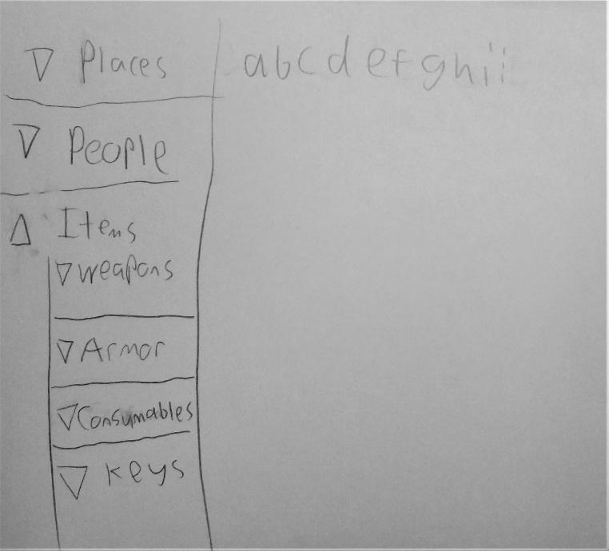

**1: Record information about an important game event**

The user begins on the ‘notes’ page where they can type any notes that they find

important for the game, as well as record what items they’ve obtained and places they’ve been.

‘notes’ are separated by hitting the enter key.

**2: Recall specific information about a game event**

**3: Edit information about a non-player character that has changed**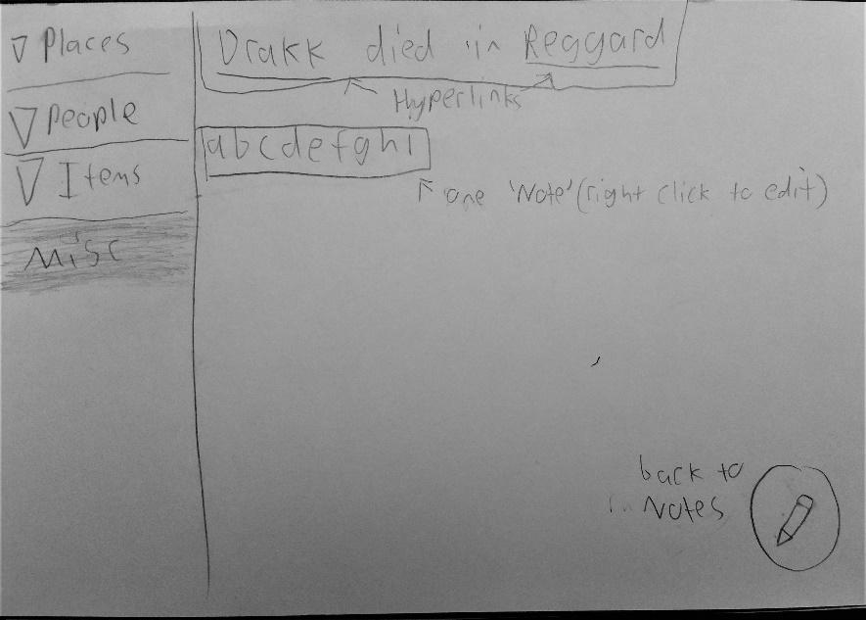

By selecting a category, the user can both view the notes that they’ve written, and edit

the notes by simply right-clicking the note block. Additionally, notes can be made to link to

other entries, making navigation significantly faster.

**4: Sort information about the word and characters**

Once a note is written, it is then dragged by the user to an existing page, or given one of its own. There is also a Misc. section for notes that don’t fall into any particular category. Categories can be given subcategories that take the form of nested drop-down menus.

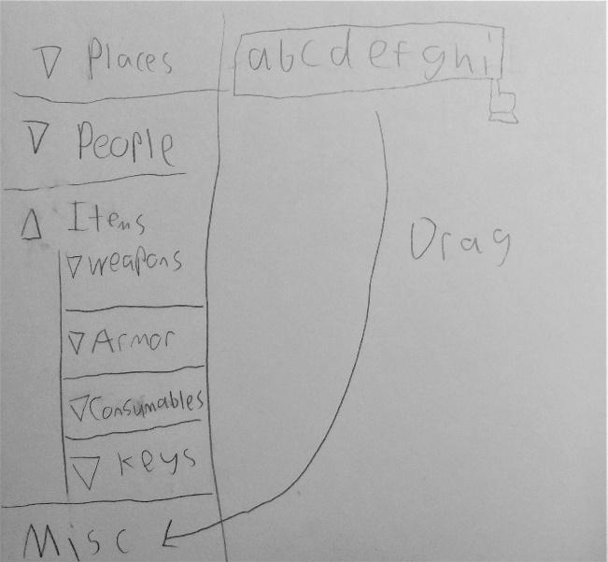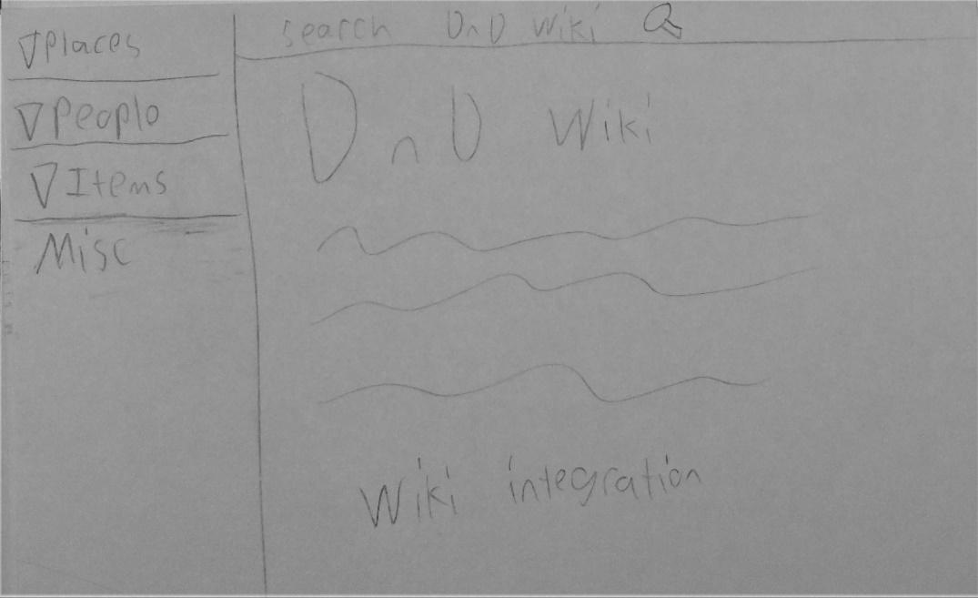

**6:** **Get information about a setting from an outside source**

The user can access a search bar by hovering their mouse over the very top of the screen. This search bar can be used to search the official Dungeons and Dragon’s wiki for information about factions, locations and items that are part of the D&D rulebooks.

**Design 2:**

Overview: a mobile voice recorder that allows users to quickly record a player or dungeon master’s statements. These recordings can be trimmed down and tagged to make the information much faster to find.

**Task 1: Record**

**information about an**

**important game event**

At any point the user may press the record button to begin recording the game using their phone’s mic. The recording can be stopped manually, set to a timer, if a speaker says “Stop recording”

**Task 2: Recall specific information about a game event**

At any point the user may press the record button to begin recording the game using their phone’s mic. These recordings can be named and replayed at later. The advantage of this design is that the player can quickly store the events of the game verbatim. Thus, totally eliminating erroneous info.

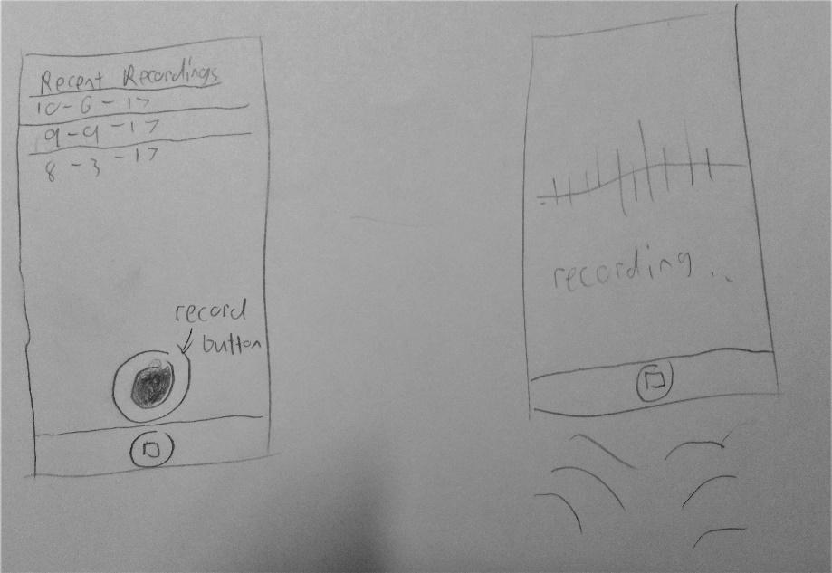

(This picture shows both tasks 1 and 2)

**Task 3: Edit information about a non-player character that has changed**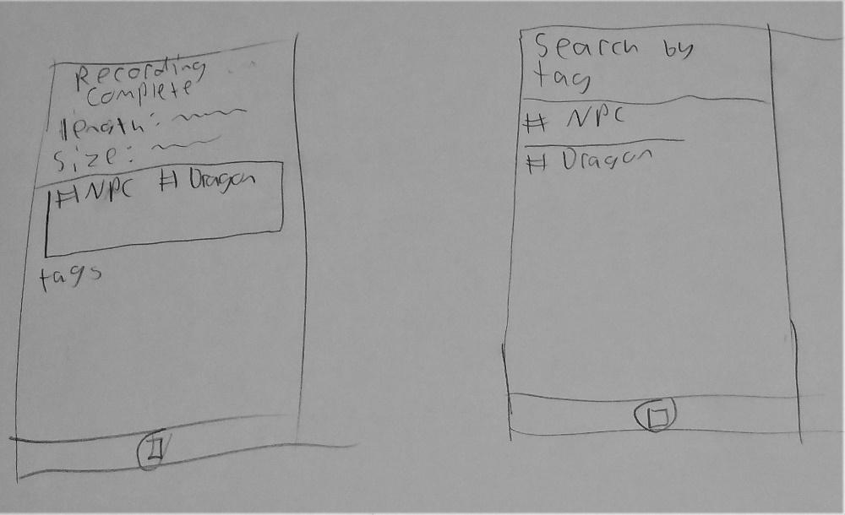

Once complete, recordings can be trimmed down to eliminate superfluous info or to apply audio effects like equalizing the volume levels or focusing on one speaker’s voice. (This picture shows both tasks 3 and 4)

**Task 4: Sort information about the word and characters**

After recording, users can take the sound byte and apply a tag to group together recordings by category and/or date. Tags can be edited at any time or grouped together

**Design 3:**

Overview: a note taking app with basic categories, and sharing features. Notes can be written in blocks and organized into different tabs or shared with other users. A friend’s list is also available and shared tabs can be used to pass notes between a group of users.

**Task 1: Record information about an important game event**

The information when typed down will appear both in the text bar and the bubble. When a thought is done and the user presses Enter, the text will be saved to the bubble on the draw screen, which allows for quick information storage and movement, as shown in a later task.

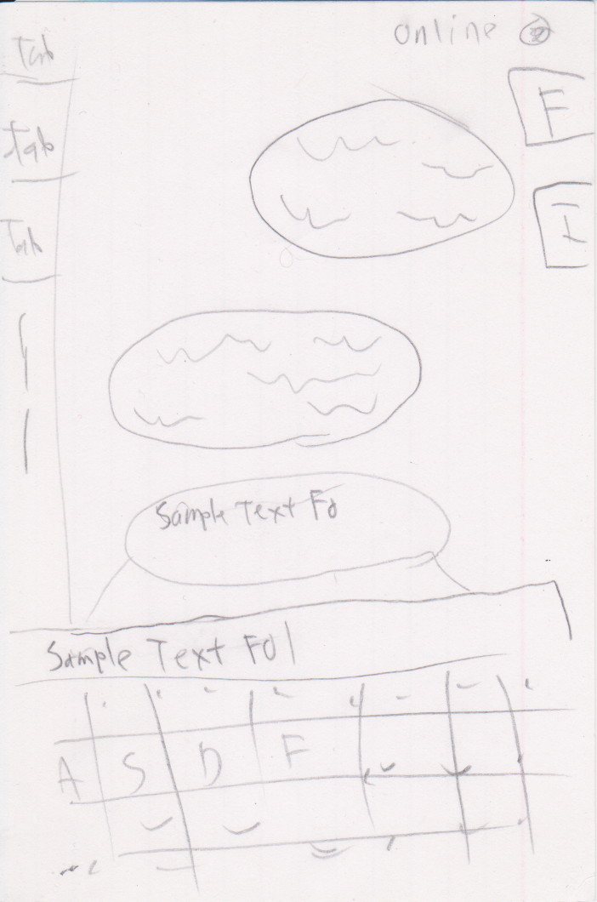

**Task 4: Sort information about the word and characters**

Once the information has been stored to a bubble in the draw screen, you can drag these bubbles into the tab you want them sorted into, which takes no time to do. The tabs are also quick to create, requiring only pressing the + button below the lowest tab and typing in a 1-word explanation. Once information has been placed into a tab, it can also be moved or copied into other tabs just as easily

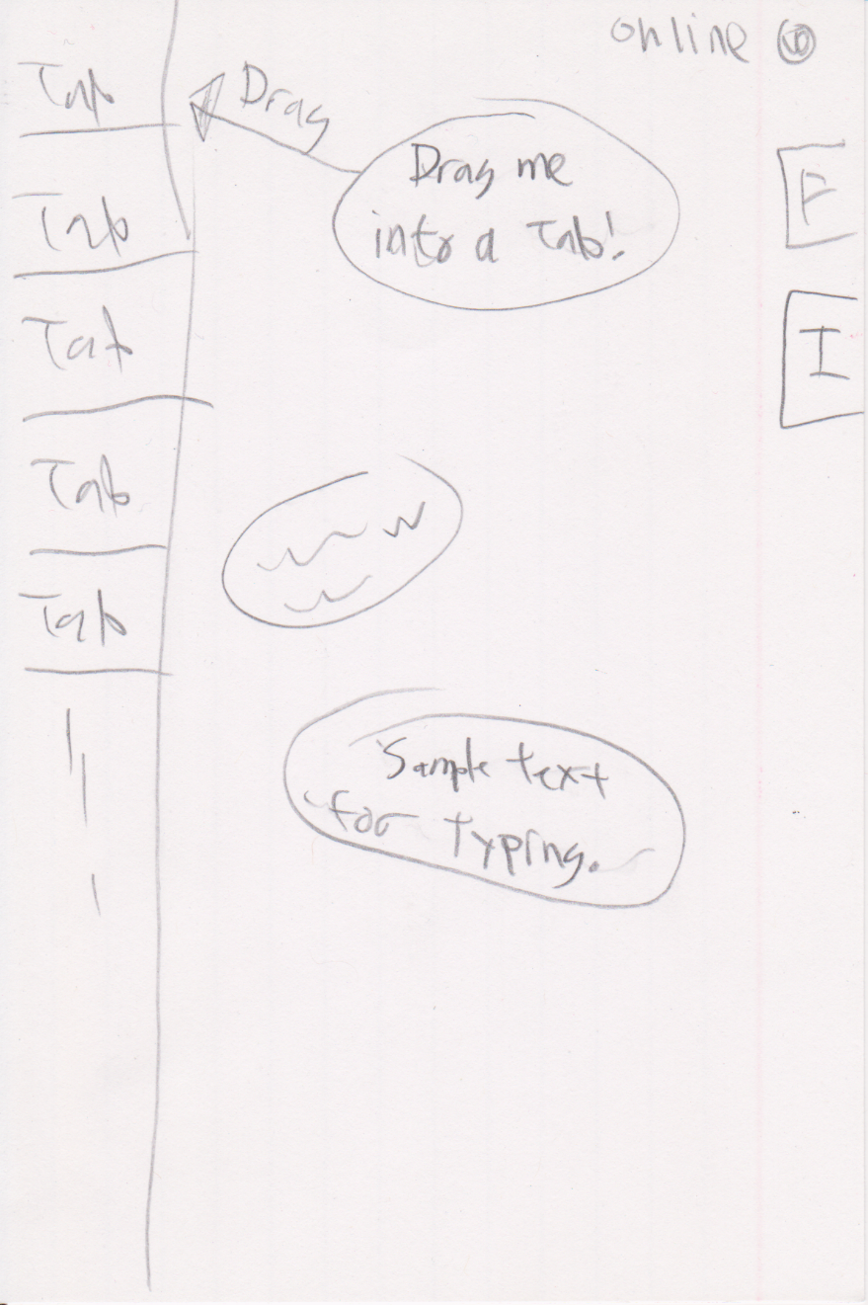

**Task 5: Sharing information**

Once information has been stored in any way, bubble or in a tab, you can open the Friend tab and drag the information box or bubble to one of the people there, and it will be sent to their draw page as a new bubble, and they can sort it however they want, or remove it if they don’t need it

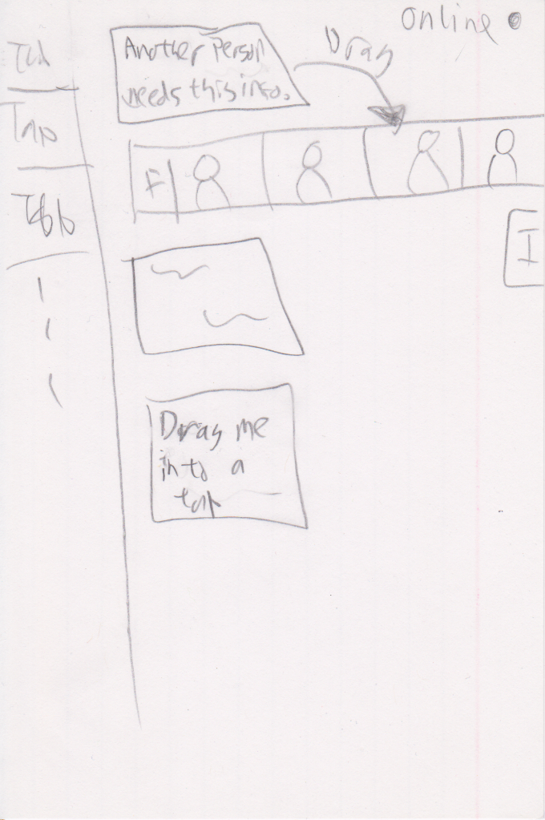

**Task 6: Get information about a setting from an outside source**

If you need info that is stored at any URL, you can type it in into the Internet tab and draw a box around what info you want, quickly pasting it into your Draw page or one of your sorted tabs, and this info acts the same as any other type of information, being able to be copied and shared.

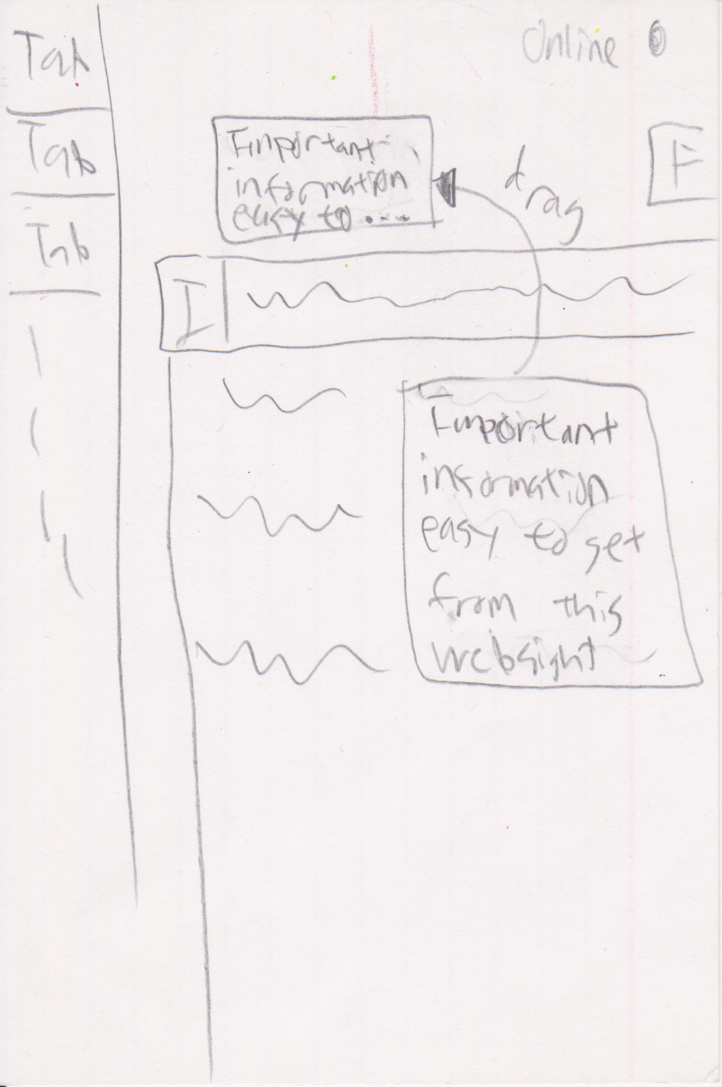

**Selected Design**

The design that we chose is a marriage of designs 1 and 2 with a lot automation added in. It has a UI just like the wiki or mobile app with a notes section and the ability to move notes into user-created tabs. Statements made by the dungeon master are recorded and sent to the players in a text format similar to a chat log. Players can then move statements made by the dungeon master into their tabs, just like regular notes. Additionally, when the dungeon master says the name of a user-created tab, that text will become a hyperlink to the tab. This design allows the player to instantly save and recall information dictated by the dungeon master. With this design, a user can easily participate without typing their own notes.

**Written Scenarios**

**Task 1:**Greg is playing a tabletop RPG and just heard the dungeon master say something important: apparently the city of Mcguffin was built on a dwarven catacomb! Could this be the reason behind all the spooky happennings recently? Greg decides that he needs to remember this in case it happens to come up later in the game. He selects the text block that the dungeon master just dictated, as well as the one before it, for good measure. He then drags then into the “Mcguffin” tab. When the group meets a week later, the party is tasked with saving Mcguffin from the recent surge of ghosts attacks. Luckily, when the DM says ‘Mcguffin’ a hyperlink to the “Mcguffin” tab appears in Greg’s chat log. Greg clicks the link and sees his notes from before. Now that he’s properly informed, he tells the group “Hey, remember the catacombs? I think we should check there.”

**Task 2:**Luke prefers to take his own notes rather than use the notes provided for him. However, he didn’t have time to organize all of them mid game. His note sheet is just a huge page of disjointed statements like ‘Artemis got the sword of infernos’ or ‘Makkar’s tavern doesn’t serve paladins’. Luckily, he took his notes using the desktop app. Luke creates sub-tabs for Artemis, Makkar and anyone else in his notes under the ”People” tab. He quickly grabs the note-blocks he typed during the game and drags them into the sub-tabs. To make navigating his notes even faster, he adds hyperlinks, so that any mentions of a person links to their respective tabs. But he still has a bunch of notes on items, so he starts again under the ‘Items’ tab. Now all of his info is sorted any easily accessible at any point during the next game.

**Task Storyboards**

**Task 1:**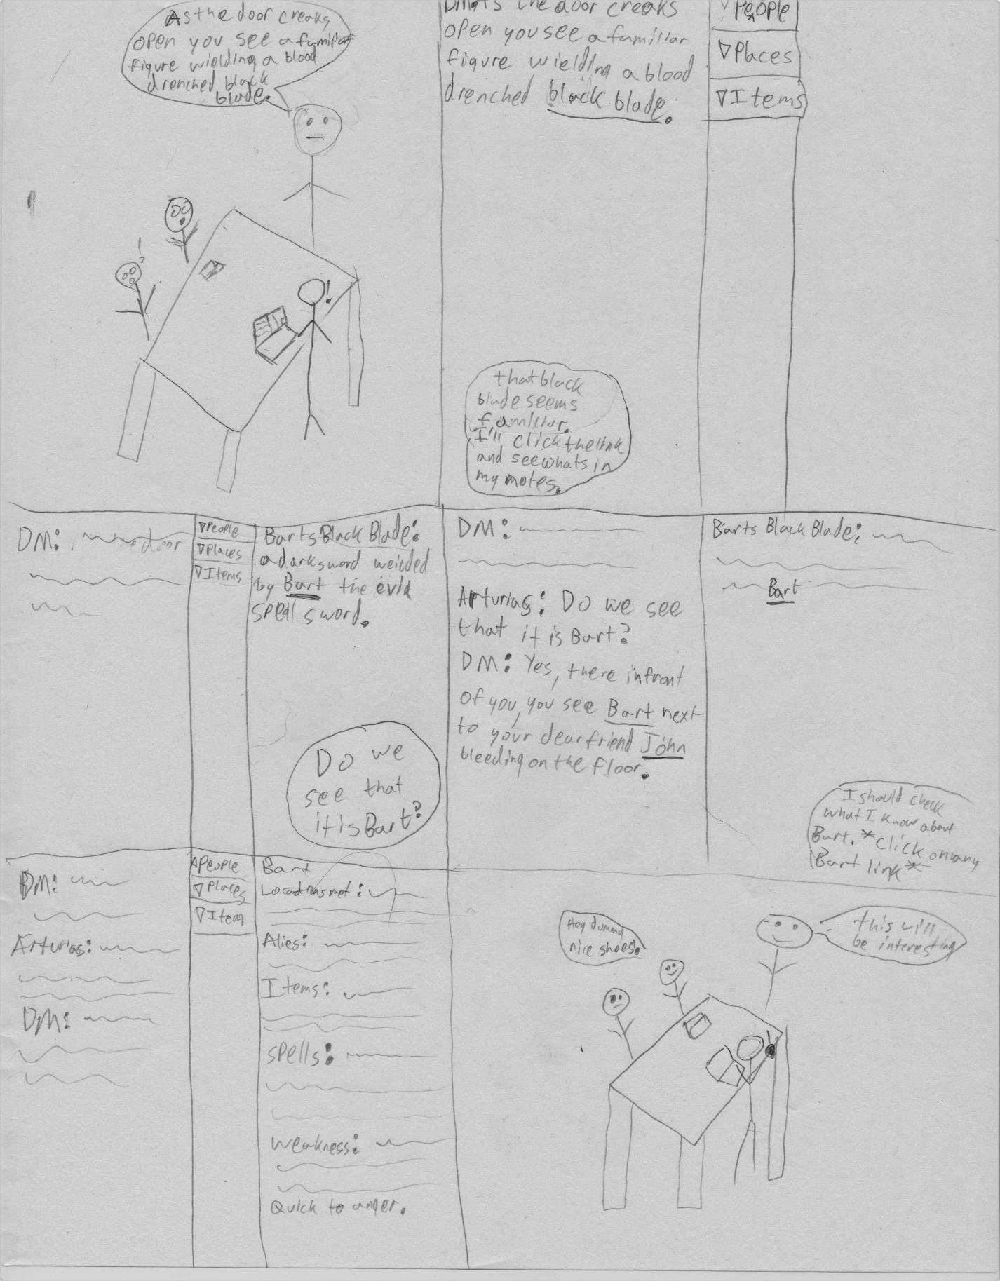

**Task 2:**